Through Balls and Final Third Finishing
95 minute soccer session plan | 23 players | Coach __________________
Develop the timing of forward runs, the weight of passes behind defenders, and composed finishing. Progress from ball control to transition play, finishing combinations, and a conditioned game.

Session schedule
Time | Activity | Duration
0–10 | Warmup | 10 min
10–20 | Arrival soccer tennis | 10 min
20–40 | Through balls in transition | 20 min
40–60 | Final third finishing | 20 min
60–90 | Attacking game | 30 min
90–95 | Cooldown and review | 5 min

Equipment and organization
Bring at least 12 balls, 40–50 cones, two sets of 11 bibs plus a neutral bib, and 2–4 mini goals. Cone gates replace extra goals during station work. Set up stations before arrival and include rotations and water within activity time.

Warmup from minute 0 to 10
Complete your usual 10 minute team warmup before soccer tennis. Build from movement and mobility into ball work and progressive accelerations.

Coaching language
- Look up before the pass. Release when the runner can arrive first.
- Curve or delay the run; accelerate as the passer looks up.
- Pass into the runner’s path. Take the first touch toward the finish.

Cooldown and review from minute 90 to 95
Two minutes of easy walking and gentle mobility, then three minutes to review: What tells you the through ball is on? How did your run help the passer? Ask players to identify one successful example.

Arrival soccer tennis
10–20 minutes | 10 minutes
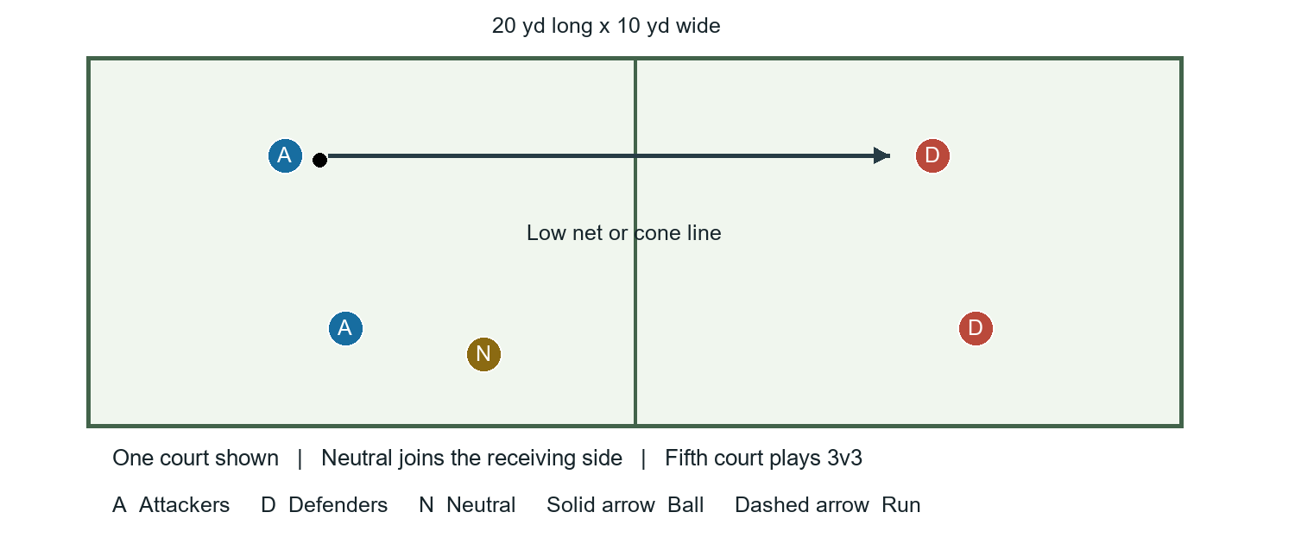

Setup
Set five courts, each 20 x 10 yards, with a center cone line or low net. Four courts play 2v2 and one plays 3v3, using 22 players. Player 23 is a roaming neutral who joins the receiving side. Use one ball per court; mini goals are optional targets for a variation.

How to play
- Start with a controlled serve across the middle. The receiving side combines and returns the ball inside the opposite half.
- Allow one bounce and up to three team touches initially. A second bounce or a ball out gives the other side a point.
- Rotate opponents and the neutral every two minutes. Keep rallies moving with spare balls.

Coaching points
- Communicate early and adjust your feet before contact.
- Use a controlled first touch and an accurate return. Support your partner at an angle.

Variations
Easier: permit two bounces or a catch to restart a broken rally. Harder: remove the bounce or limit players to one or two touches. Optional goal version: award a bonus for a controlled return through a target gate.

Through balls in transition
20–40 minutes | 20 minutes
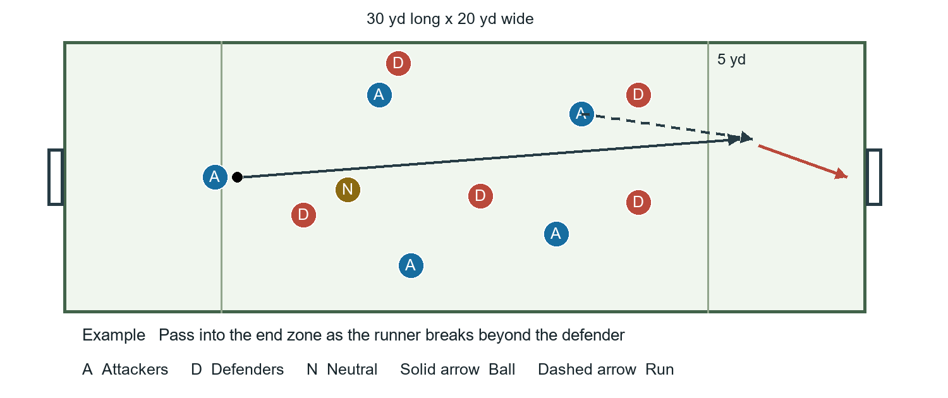

Setup
Use two 30 x 20 yard grids, each with a mini goal or cone gate at both ends and a 5 yard end zone. Grid A plays 5v5 plus a neutral; Grid B plays 6v6. The neutral supports possession. Widen a grid if congestion prevents passing lanes.

How to play
- Play four five-minute rounds, including short resets. On a turnover, attack the opposite goal immediately.
- A goal counts only after a forward pass into the attacking end zone reaches a teammate running in from outside it. Players cannot wait in the end zone.
- After receiving, finish promptly. Defenders can recover into the zone. Restart from the conceding team’s end after a goal; rotate the neutral and matchups between rounds.

Coaching points
- Scan for a forward lane immediately after winning possession.
- Pass ahead of the runner with enough pace to beat the defender.
- Delay the run until the passer can release; stay wide enough to open a lane.

Variations
Easier: widen the grid or allow a free first touch after a regain. Harder: use two touches in midfield while keeping the receiver free to finish.

Final third finishing
40–60 minutes | 20 minutes
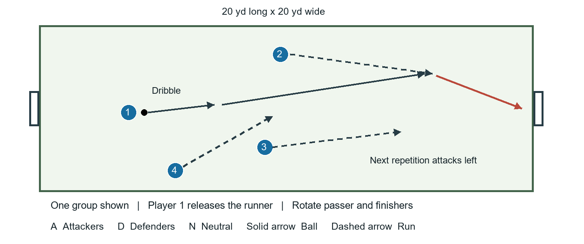

Setup
Set five 20 x 20 yard grids with goals or cone gates on opposite sides. Use groups of 4, 4, 5, 5 and 5. Four players work per repetition; in groups of five, the spare player serves or retrieves and rotates in after each attempt. Use one active ball and a spare per grid.

How to play
- The ball carrier dribbles forward. Three teammates make different supporting runs: one beyond, one across and one underneath.
- The carrier passes to a forward runner, who finishes after receiving. No direct goal by the original dribbler.
- One attack per grid at a time. Retrieve the ball and attack the opposite end on the next repetition. Rotate the passer every attempt; change starting positions every five minutes.

Coaching points
- Create separation before accelerating into the passing lane.
- Keep the pass in front of the runner; avoid forcing the receiver to stop.
- Look at the target before striking. Use a settling touch when needed.

Variations
Easier: allow a touch to set the ball before shooting. Harder: require a one-touch finish. In groups of five, the extra player can become a recovering defender once the passing pattern is secure.

Attacking game with through balls
60–90 minutes | 30 minutes
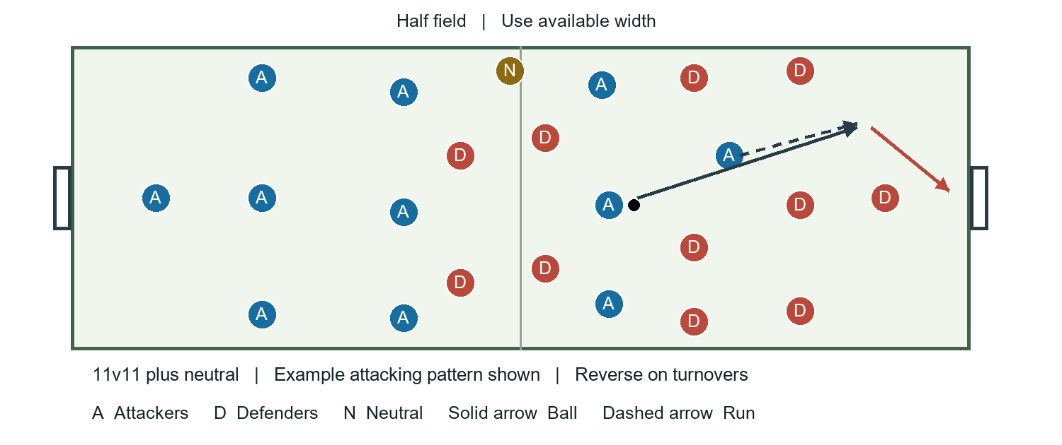

Setup
Use half a field with one mini goal at each end, two goals total. Play 11v11 plus a neutral who supports possession. Use the available width; widen or lengthen if the pitch is too crowded. Play without goalkeepers and do not allow players to stand in the goal mouth.

How to play
- Play three ten-minute blocks, including brief water and feedback. Rotate the neutral at each break.
- First block: goals count only after a through ball behind the defensive line. Apply offside in the attacking half, judged by the coach.
- Second block: all goals count one; a goal from a through ball counts two. Final block: remove scoring conditions and observe whether players choose the pass at the right moment.
- On a turnover, the neutral immediately supports the new team. Restart quickly from the end line after goals and with a pass-in from touchlines.

Coaching points
- Create width and depth so the ball carrier has a forward option.
- Recognize when to play through and when to keep possession.
- Support the runner for a second pass, rebound or finish. Praise well-timed runs even when the final pass misses.

Variations
Easier: give the neutral unlimited touches and encourage early forward support. Harder: limit midfield players to two touches. With 22 players, remove the neutral and play 11v11.

